DEPARTMENT OF MECHNICAL ENGINEERING
Mechanical Head of Department In-Charge HOD
Name: Dr. P N JYOTHI
Designation: Professor & Head (In-Charge)
Qualification: M.Tech, Ph.D
Department: MECHANICAL ENGINEERING
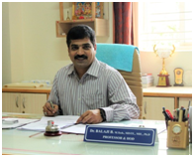
Dr. BALAJI B
Principal (In-Charge), Associate Director, Admissions & PR.
M.Tech, MISTE, MIE, Ph.D
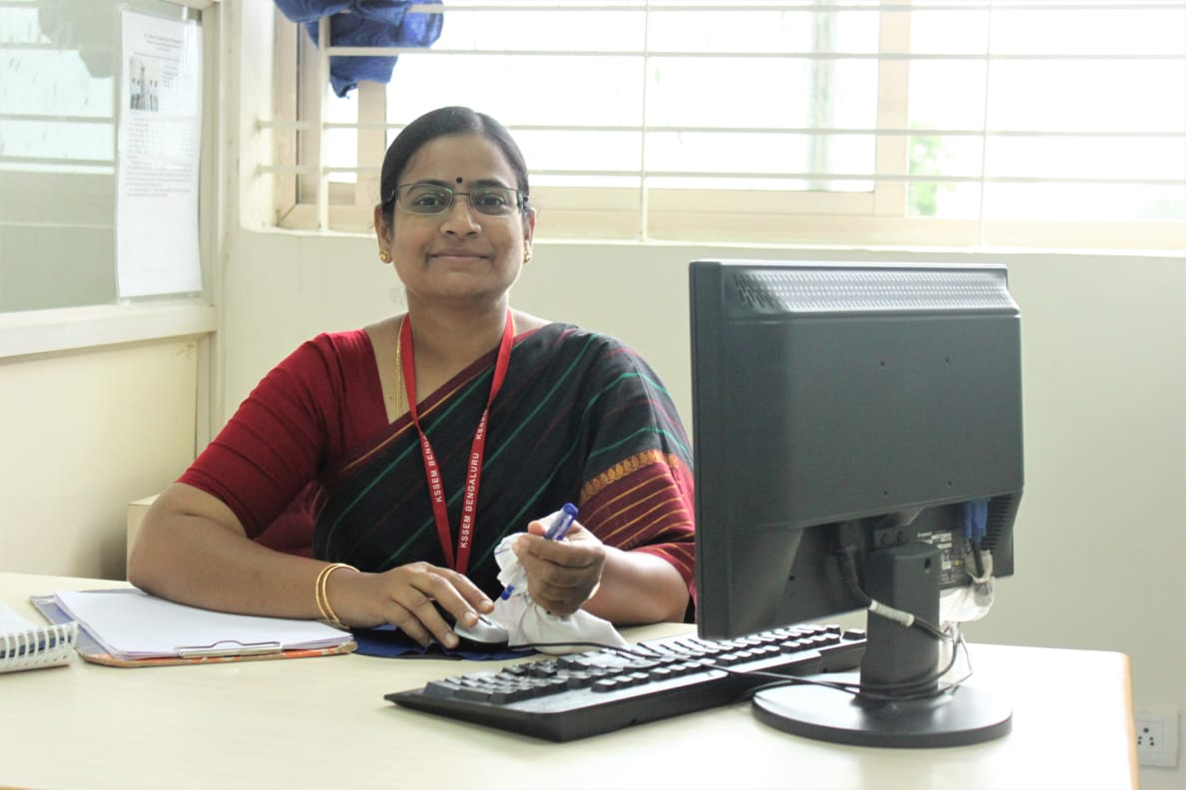
Dr. P N JYOTHI
Professor & Head (In-Charge)
M.Tech, Ph.D
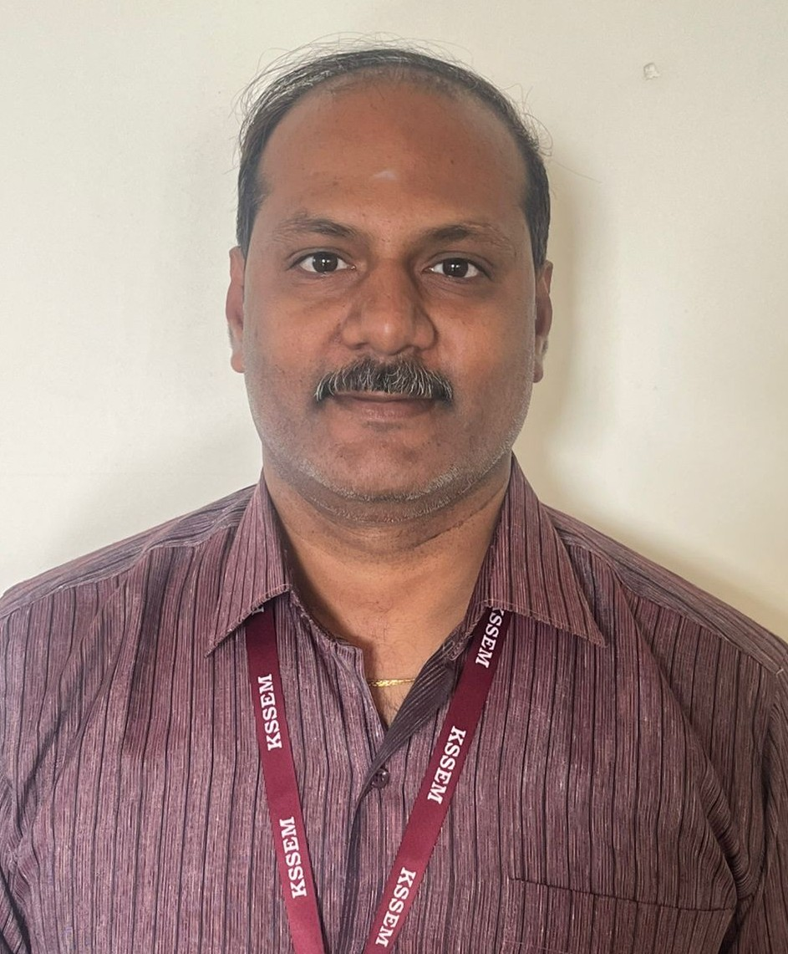
Dr. ABHISHEK M R
Associate Professor
M. Tech., Ph.D

AKASH DEEP B N
Assistant Professor
M.Tech, (Ph.D)
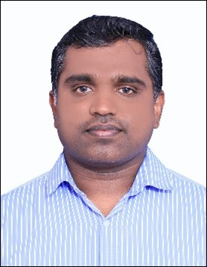
SANTOSH KUMAR K J
Assistant Professor
M.Tech (Ph. D)

Dr. PARASHURAM A KUTAKANAKERI
Assistant Professor
M.Tech, Ph.D

BASAVARAJA K T
Assistant professor
M.Tech, (Ph.D)

HARISHA P
Assistant Professor
M.Tech

GAYATHRI SANGAPPA PUJARI
Assistant Professor
M.Tech
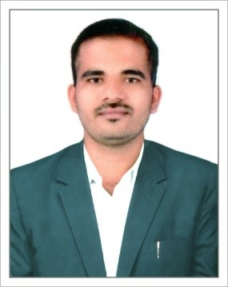
SWAROOP POONAYKAR B K
Assistant Professor
M.Tech
Supporting Faculty
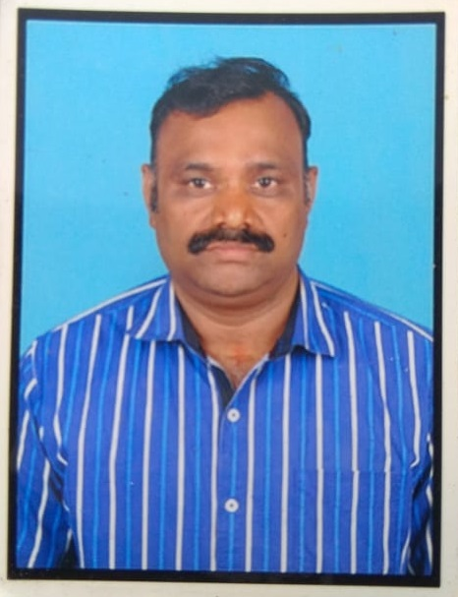
Mr.B.N.SATISH
FOREMAN
DME. (BE)

Mr.M.DEVARAJULU
INSTRUCTOR
I T I
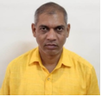
Mr.N.DHOORAVASULU
WELDER
SSLC

Mr.LOKESH.E
TECHNICIAN
I T I

Mrs REKHA D
Office Assistant
BA

Smt.VINAYAKAMMA
ATTENDER
SSC

Mr.RAVI.H.K
ATTENDER
SSC

Mr. MANJUNATH V
ATTENDER
10TH
Welcome to the Department of Mechanical Engineering, where we lay the foundation for tomorrow?s engineers to design, innovate, and optimize the mechanical systems that power the world.
The Mechanical Engineering program focuses on the design, analysis, and manufacturing of mechanical systems. Students will gain a strong understanding of core engineering principles, including mechanics, thermodynamics, fluid dynamics, materials science, and control systems. The curriculum integrates theoretical knowledge with practical experience, offering hands-on opportunities in laboratories, workshops, and real-world projects.
Graduates of this program are prepared to work in a variety of industries, such as automotive, aerospace, manufacturing, energy, robotics, and HVAC. Career paths include roles like mechanical design engineer, thermal systems engineer, manufacturing engineer, robotics engineer, and project manager. With advances in automation, smart manufacturing, and sustainable energy solutions, the demand for skilled mechanical engineers continues to grow across the globe.

Vision
  - To create a platform for fulfilling the changing needs of Mechanical Engineering domain through constant up-gradation and research work.\

MISSION
Department of Mechanical Engineering shall,
- Promote the professional passion amongst students through exposure to recent advancements.
- Build partnerships with industries to impart technical exposure and knowledge.
- Impart ethics by quality teaching and research work through continuous improvements.

